CUSTOMER CHURN ANALYSIS REPORT

1. Project Overview

2. Dataset Summary

3. Data Cleaning & Analysis (Python)

4. Data Analysis (SQL)
1. Overall Churn KPIs — the executive summary numbers
SELECT
COUNT(customerid) AS total_customers,
SUM(churn_flag) AS total_churned,
COUNT(customerid) - SUM(churn_flag) AS total_retained,
ROUND(SUM(churn_flag) * 100.0 / COUNT(customerid), 2) AS churn_rate_pct,
ROUND(AVG(monthlycharges), 2) AS avg_monthly_charges,
ROUND(SUM(churn_flag * monthlycharges), 2) AS monthly_revenue_at_risk,
ROUND(SUM(churn_flag * monthlycharges) * 12, 2) AS annual_revenue_at_risk
FROM telco_churn_data;

2. Churn Rate by Contract Type
SELECT
contract,
COUNT(customerid) AS total_customers,
SUM(churn_flag) AS churned,
ROUND(SUM(churn_flag) * 100.0 / COUNT(customerid), 2) AS churn_rate_pct,
ROUND(AVG(monthlycharges), 2) AS avg_monthly_charges,
ROUND(SUM(churn_flag * monthlycharges) * 12, 2) AS annual_rev_at_risk
FROM telco_churn_data
GROUP BY contract
ORDER BY churn_rate_pct DESC;
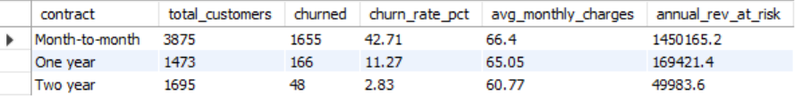
3. Avg Monthly Charges — Churned vs Retained
SELECT
churn AS churn_status,
COUNT(customerid) AS customers,
ROUND(AVG(monthlycharges), 2) AS avg_monthly_charges,
ROUND(MIN(monthlycharges), 2) AS min_monthly_charges,
ROUND(MAX(monthlycharges), 2) AS max_monthly_charges,
ROUND(AVG(totalcharges), 2) AS avg_total_charges,
ROUND(AVG(tenure), 1) AS avg_tenure_months
FROM telco_churn_data
GROUP BY churn
ORDER BY churn DESC;
4. High-Risk Customer Segment
SELECT
COUNT(customerid) AS segment_size,
SUM(churn_flag) AS churned,
ROUND(SUM(churn_flag) * 100.0 / COUNT(customerid), 2) AS segment_churn_rate_pct,
ROUND(SUM(churn_flag * monthlycharges) * 12, 2) AS annual_rev_at_risk,
ROUND(AVG(monthlycharges), 2) AS avg_monthly_charges,
-- Benchmark vs overall churn rate
(SELECT ROUND(SUM(churn_flag) * 100.0 / COUNT(customerid), 2)
FROM telco_churn_data) AS overall_churn_rate_pct
FROM telco_churn_data
WHERE contract = 'Month-to-month'
AND internetservice = 'Fiber optic'
AND techsupport = 'No'
AND onlinesecurity = 'No';
5. Revenue at Risk
SELECT
contract,
internetservice,
COUNT(customerid) AS total_customers,
SUM(churn_flag) AS churned_customers,
ROUND(SUM(churn_flag) * 100.0 / COUNT(customerid), 2) AS churn_rate_pct,
ROUND(SUM(churn_flag * monthlycharges), 2) AS monthly_rev_lost,
ROUND(SUM(churn_flag * monthlycharges) * 12, 2) AS annual_rev_lost
FROM telco_churn_data
GROUP BY contract, internetservice
ORDER BY annual_rev_lost DESC;
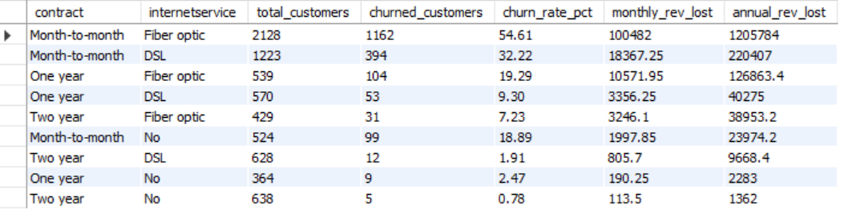
6. Customers with >24 Months Tenure Who Still Churn
SELECT
contract,
internetservice,
paymentmethod,
COUNT(customerid) AS long_tenure_churners,
ROUND(AVG(tenure), 1) AS avg_tenure_months,
ROUND(AVG(monthlycharges), 2) AS avg_monthly_charges,
ROUND(AVG(totalcharges), 2) AS avg_total_charges,
ROUND(SUM(monthlycharges) * 12, 2) AS annual_rev_lost
FROM telco_churn_data
WHERE tenure > 24
AND churn_flag = 1
GROUP BY contract, internetservice, paymentmethod
ORDER BY long_tenure_churners DESC;

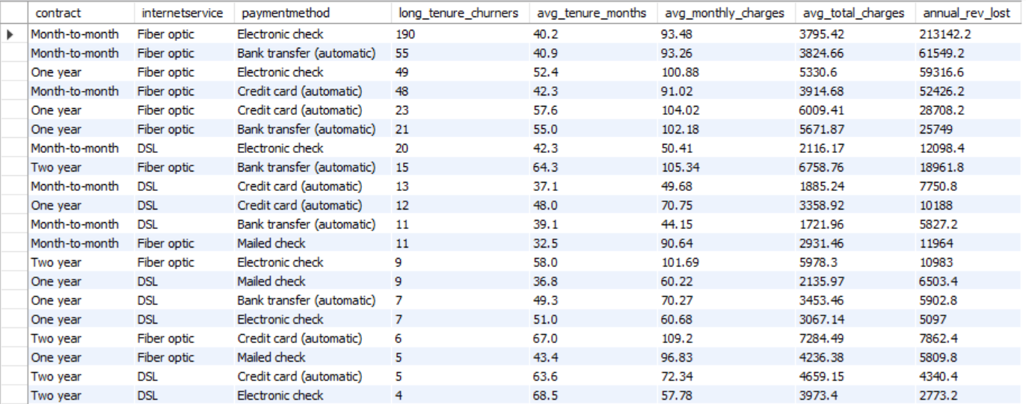

7. Churn Rate by Payment Method
SELECT
paymentmethod,
COUNT(customerid) AS total_customers,
SUM(churn_flag) AS churned,
ROUND(SUM(churn_flag) * 100.0 / COUNT(customerid), 2) AS churn_rate_pct,
ROUND(AVG(monthlycharges), 2) AS avg_monthly_charges
FROM telco_churn_data
GROUP BY paymentmethod
ORDER BY churn_rate_pct DESC;
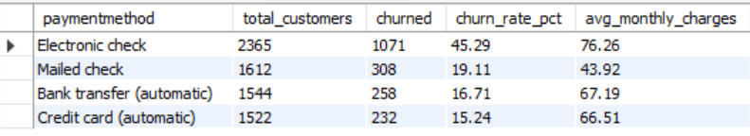
8. Impact of Add-on Services on Churn
SELECT
techsupport,
onlinesecurity,
COUNT(customerid) AS customers,
SUM(churn_flag) AS churned,
ROUND(SUM(churn_flag) * 100.0 / COUNT(customerid), 2) AS churn_rate_pct,
ROUND(AVG(monthlycharges), 2) AS avg_monthly_charges
FROM telco_churn_data
WHERE internetservice != 'No' -- only customers with internet
GROUP BY techsupport, onlinesecurity
ORDER BY churn_rate_pct DESC;
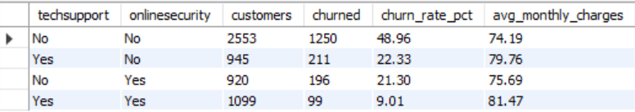
9. Churn by Tenure Group with Revenue Impact
SELECT
CASE
WHEN tenure BETWEEN 0 AND 12 THEN '0–12 mo'
WHEN tenure BETWEEN 13 AND 24 THEN '13–24 mo'
WHEN tenure BETWEEN 25 AND 36 THEN '25–36 mo'
WHEN tenure BETWEEN 37 AND 48 THEN '37–48 mo'
WHEN tenure BETWEEN 49 AND 60 THEN '49–60 mo'
ELSE '61–72 mo'
END AS tenure_group,

COUNT(customerid) AS total_customers,
SUM(churn_flag) AS churned,
ROUND(SUM(churn_flag) * 100.0 / COUNT(customerid), 2) AS churn_rate_pct,
ROUND(AVG(monthlycharges), 2) AS avg_monthly_charges,
ROUND(SUM(churn_flag * monthlycharges) * 12, 2) AS annual_rev_at_risk

FROM telco_churn_data
GROUP BY
CASE
WHEN tenure BETWEEN 0 AND 12 THEN '0–12 mo'
WHEN tenure BETWEEN 13 AND 24 THEN '13–24 mo'
WHEN tenure BETWEEN 25 AND 36 THEN '25–36 mo'
WHEN tenure BETWEEN 37 AND 48 THEN '37–48 mo'
WHEN tenure BETWEEN 49 AND 60 THEN '49–60 mo'
ELSE '61–72 mo'
END
ORDER BY MIN(tenure);
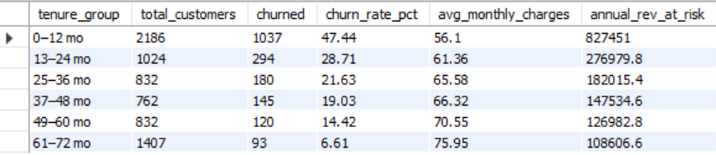

10. Top 3 Churning Profiles Using Window Function
WITH profile_churn AS (
SELECT
contract,
internetservice,
techsupport,
paymentmethod,
COUNT(customerid) AS total_customers,
SUM(churn_flag) AS churned,
ROUND(SUM(churn_flag) * 100.0 / COUNT(customerid), 2)
AS churn_rate_pct,
ROUND(SUM(churn_flag * monthlycharges) * 12, 2) AS annual_rev_at_risk
FROM telco_churn_data
GROUP BY contract, internetservice, techsupport, paymentmethod
HAVING COUNT(customerid) >= 50 -- exclude tiny segments
),
ranked AS (
SELECT
*,
ROW_NUMBER() OVER (ORDER BY churn_rate_pct DESC) AS risk_rank
FROM profile_churn
)
SELECT
risk_rank,
contract,
internetservice,
techsupport,
paymentmethod,
total_customers,
churned,
churn_rate_pct,
annual_rev_at_risk
FROM ranked
WHERE risk_rank <= 10
ORDER BY risk_rank;
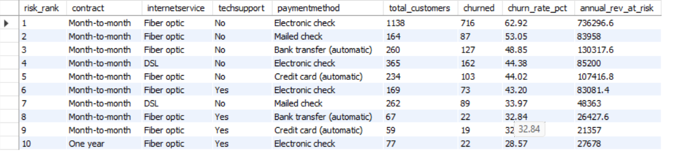

5. Exploratory Insights

6. Dashboard (Power BI)

7. Business Recommendations

